Pentagrammic Rotunda
# Source: AI Source: Provided by: [Data Path: Persons Table -> ID Column: 1, Name_En Column: Motasem Essam] -> From: [ChatGPT] on [7/25/2026]
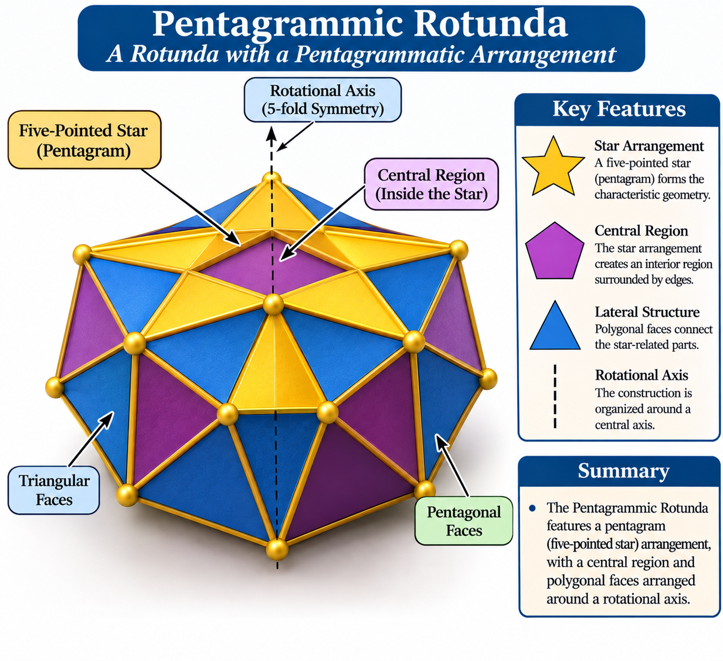

Definition
# Source: AI Source: Provided by: [Data Path: Persons Table -> ID Column: 1, Name_En Column: Motasem Essam] -> From: [ChatGPT] on [7/25/2026]
A Pentagrammic Rotunda is a star-rotunda-type polyhedron associated with a pentagrammic (five-pointed star) arrangement.
It is listed as one of the four named star-rotunda variants, alongside the Heptagrammic, Enneagrammic, and Hendecagrammic Rotundas. <Cite refs={["turn547019search12","turn547019search3"]}/>
Important distinction: The Pentagrammic Rotunda is not the same solid as the ordinary Pentagonal Rotunda (Johnson solid J6). The ordinary Pentagonal Rotunda has a regular pentagon and decagon as its bases; the Pentagrammic Rotunda belongs to the star-rotunda category.

Geometric Structure
# Source: AI Source: Provided by: [Data Path: Persons Table -> ID Column: 1, Name_En Column: Motasem Essam] -> From: [ChatGPT] on [7/25/2026]
Its defining geometric feature is the pentagrammic arrangement:
- Star Arrangement: A five-pointed star pattern forms the characteristic geometry.
- Central Region: The star arrangement creates an interior region surrounded by intersecting or connected edges.
- Lateral Structure: Polygonal faces connect the star-related parts of the solid.
- Rotational Axis: The construction is organized around a central axis associated with the fivefold arrangement.
The exact base polygons, lateral face shapes, and spatial arrangement must be established from a specific geometric model; they should not be inferred solely from the name.

Geometric Characteristics
# Source: AI Source: Provided by: [Data Path: Persons Table -> ID Column: 1, Name_En Column: Motasem Essam] -> From: [ChatGPT] on [7/25/2026]
- Solid Type: Star-rotunda-type polyhedron.
- Defining Polygonal Arrangement: Pentagram.
- Principal Points: 5.
- Rotational Pattern: Fivefold arrangement.
- Geometric Nature: Star-shaped construction.
- Convexity: A star arrangement can produce non-convex or intersecting geometry.
- Face Composition: Depends on the specific construction.
- Mathematical Counts: No verified universal face, edge, or vertex counts are established here.

Construction of Pentagrammic Rotunda

Geometric Instruments Used
# Source: AI Source: Provided by: [Data Path: Persons Table -> ID Column: 1, Name_En Column: Motasem Essam] -> From: [ChatGPT] on [7/25/2026]
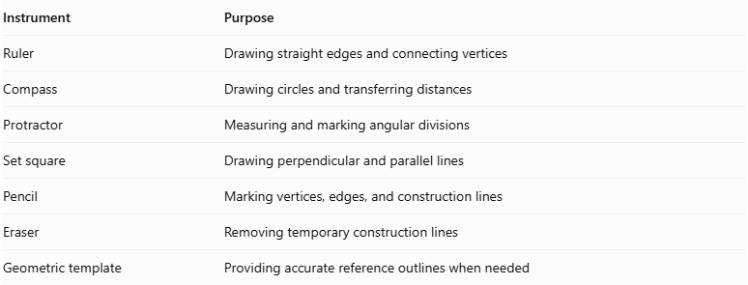
Instrument | Purpose
Ruler | Drawing straight edges and connecting vertices
Compass | Drawing circles and transferring distances
Protractor | Measuring and marking angular divisions
Set square | Drawing perpendicular and parallel lines
Pencil | Marking vertices, edges, and construction lines
Eraser | Removing temporary construction lines
Geometric template | Providing accurate reference outlines when needed

Instrument-Based Construction Procedures

Constructing the Pentagram
# Source: AI Source: Provided by: [Data Path: Persons Table -> ID Column: 1, Name_En Column: Motasem Essam] -> From: [ChatGPT] on [7/25/2026]
- Draw a circle using a compass.
- Mark five equally spaced points on its circumference.
- Label the points $A$, $B$, $C$, $D$, and $E$, in circular order.
- Connect each point to the second next point:
- $A$ to $C$
- $C$ to $E$
- $E$ to $B$
- $B$ to $D$
- $D$ to $A$
- Darken the resulting pentagram boundary.
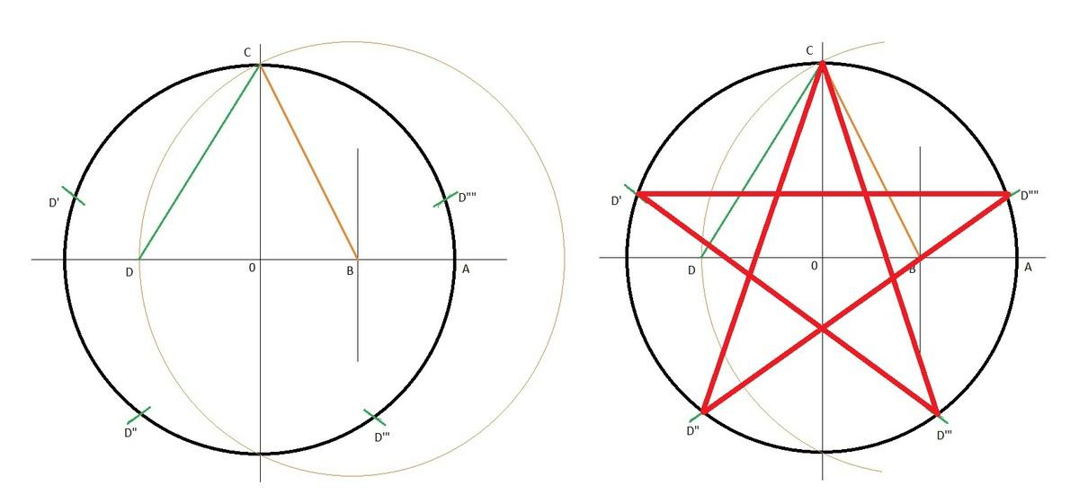

Constructing the Parallel Polygonal Arrangement
# Source: AI Source: Provided by: [Data Path: Persons Table -> ID Column: 1, Name_En Column: Motasem Essam] -> From: [ChatGPT] on [7/25/2026]
- Draw a second construction plane parallel to the first.
- Mark the corresponding reference center.
- Transfer the required vertex positions and orientation from the reference model.
- Draw the required star-shaped or polygonal boundary.
- Check the alignment of the two arrangements.

Establishing the Central Axis
# Source: AI Source: Provided by: [Data Path: Persons Table -> ID Column: 1, Name_En Column: Motasem Essam] -> From: [ChatGPT] on [7/25/2026]
- Identify the centers of the upper and lower arrangements.
- Draw a perpendicular line through the two centers.
- Extend the line to represent the central axis.
- Use this axis as the reference for the solid's symmetry and alignment.

Connecting the Upper and Lower Arrangements
# Source: AI Source: Provided by: [Data Path: Persons Table -> ID Column: 1, Name_En Column: Motasem Essam] -> From: [ChatGPT] on [7/25/2026]
- Identify the corresponding vertices in both arrangements.
- Connect the required vertices using a ruler.
- Follow the edge arrangement shown in the selected pentagrammic rotunda model.
- Check that the connections produce the intended star-shaped structure.
- Distinguish visible edges from hidden edges.

Completing the Solid Representation
# Source: AI Source: Provided by: [Data Path: Persons Table -> ID Column: 1, Name_En Column: Motasem Essam] -> From: [ChatGPT] on [7/25/2026]
- Draw the lateral boundaries and face outlines.
- Add the remaining edges according to the reference model.
- Use solid lines for visible edges.
- Use dashed lines for hidden edges.
- Erase unnecessary construction lines.
- Label the upper arrangement, lower arrangement, lateral faces, vertices, and central axis.
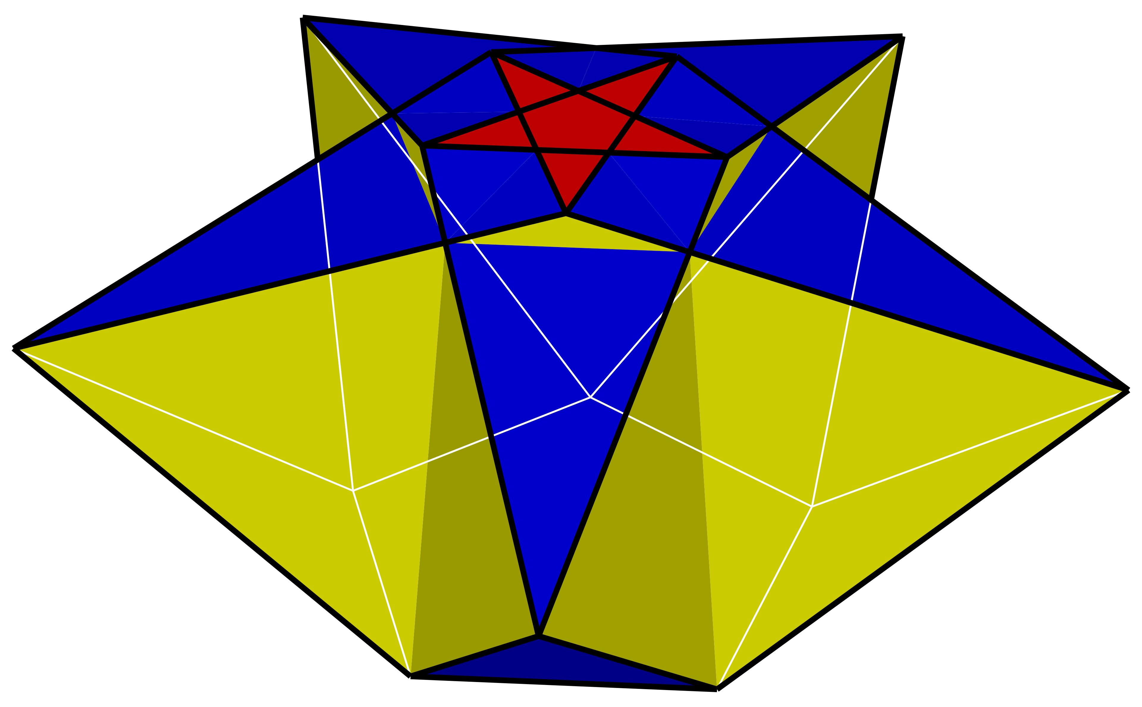

Key Points
# Source: AI Source: Provided by: [Data Path: Persons Table -> ID Column: 1, Name_En Column: Motasem Essam] -> From: [ChatGPT] on [7/25/2026]
- The Pentagrammic Rotunda belongs to the Star-Rotunda family.
- Its defining arrangement is based on a pentagram.
- It is distinct from the ordinary Pentagonal Rotunda.
- It should not be confused with the Small Stellated Dodecahedron or other Kepler–Poinsot solids.
- Its exact mathematical properties require a specified three-dimensional construction.

Main Classification
# Source: AI Source: Provided by: [Data Path: Persons Table -> ID Column: 1, Name_En Column: Motasem Essam] -> From: [ChatGPT] on [7/25/2026]
Solid Geometry
└── Types of Solids
└── Star-Rotundas
└── Types of Star-Rotundas
└── Pentagrammic Rotunda
└── Pentagrammic Arrangement

Conclusion
# Source: AI Source: Provided by: [Data Path: Persons Table -> ID Column: 1, Name_En Column: Motasem Essam] -> From: [ChatGPT] on [7/25/2026]
The Pentagrammic Rotunda is a named member of the Star-Rotunda family, characterized by a five-pointed star arrangement. Its detailed face composition and mathematical properties should be documented from a verified geometric model rather than assumed from the ordinary rotunda formulas.

